**NUR International University**

**Office of Controller Examinations**

FINAL SEMESTER EXAMINATION, Fall 2020

**IMPORTANT NOTICE FOR STUDENTS**

It is notified to you that mode of Final Examinations for the semester Fall 2020 will be **ONLINE**. All examinations will be conducted according to the schedule through **NIU-LMS in an e-proctored environment**. Please read ONLINE EXAMINATION INSTRUCTIONS (circulated/uploaded on university LMS & website) carefully well before the examinations.

You are also advised to make necessary arrangements/equipment procurement well before the exams and try them to avoid inconvenience. You are also advised to make arrangements for uninterrupted internet and electricity supply (generators, UPS) during the examinations.

As you opted for ONLINE mode of examination so it is your responsibility to ensure necessary actions to take the online exam.

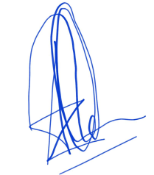 Best of luck in the forthcoming exams

Controller of Examinations

NUR International University